*VIVO mobile*

VIVO Y36

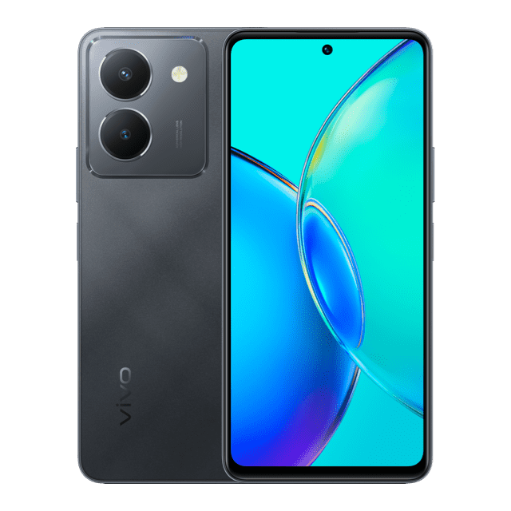

Body · Dimensions. **164.06 × 76.17 × 8.07** mm ; Basic. Color. Meteor Black Vibrant Gold ; Display. Resolution. 2388 × 1080 (FHD + ) ; Network. 2G GSM. 850/900/1800MHz.

**PRICE /** 59,999 **PRK**